**Name : Abodunrin Adeyemi Oluwasegun**

**Github link:** [**https://github.com/Yhermii/Applied-Data-Science-Visualization-1**](https://github.com/Yhermii/Applied-Data-Science-Visualization-1)

**ABSTRACT**

This analysis was done using the sixteen West African countries to explore the connections between these following factors ; C02 emission, Population growth, Gdp growth, Rural and Urban growth(annual %).

**TITLE**

CARBON(C02) EMISSION BASED ON WORLD BANK DATA

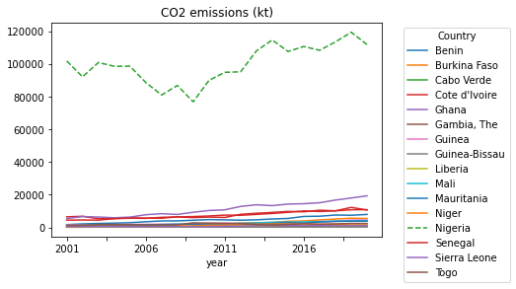

Niger has a positive relationship as the year progresses the population increases until a slight drop in 2020 which could be as a result of the pandemic.

Cabo-verde Guinea , and Guinea-Bissau have very low urban population growth which could be the reason they have low carbon emission . There is more transportation activities and large energy consumption in the urban regions and the three countries mentioned lack the growth in that area.

The line plot above shows that amongst the West African Countries , Nigeria produces

the highest Co2 over a 20 year Period 2001 to 2020. About 100,000 kilo tons are emitted per year.

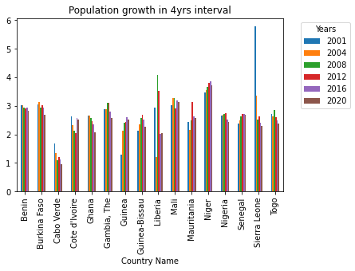

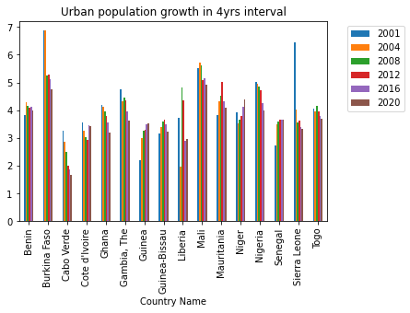

Meanwhile, Nigeria isn't the country with the

most significant population growth in the 4 years interval as shown in the graph below.

Sierra Leone experienced a massive population growth in 2001 and declined afterwards.

The correlation heat map for Nigeria below shows that the population of Nigeria has no correlation between its co2 emission .

Cabo Verde shows a decline in rural population over a 20 year period.they were further decline in 2004 and 2008 in particular.

This explains why Nigeria has the highest

Co2 emission despites not being the country that experienced the highest population growth annually over a period of the selected years

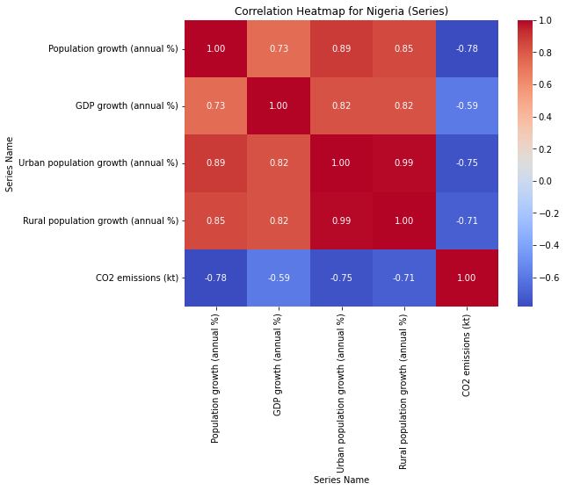although there is little correlation between the urban population and the gdp growth.

For the Sierra Leone heat map shown in the bottom right corner. It also shows that population has no correlation with co2 emission. It shows correlation between population and population and urban and rural population growth.

In conclusion, the report shows that population is not a significant factor in co2 emission . it could be other factors not considered in this data such as Transportation which contribute about 28% of the world's co2 emission, energy usage and industrial activities.

